Form 1.6. Business process architecture (Process mapping)
Process mapping can be used to assess the current end-to-end flow of activities and stakeholders, and generate an “as-is” map of the way death registration currently happens in a given setting.
Step 1: Preparation
- Review available documentation: Compile available information on the processes and information flow in mortality surveillance system (i.e., their processes and goals). [You can use Form 1.1.2. Mortality information systems]
  - Complete the desk review to map out the current mortality data systems and identify key stakeholders, data flows, and processes.
  - Use consultations with key stakeholders to gather input on stakeholders’ roles, data needs, and challenges in the current system.
- Develop a draft Business Process Map (BPM):
  - Use findings from the desk review and consultations to create a preliminary draft of the BPM.
  - Represent the key stakeholders, processes, data flows, and system components using Business Process Model and Notation (BPMN).
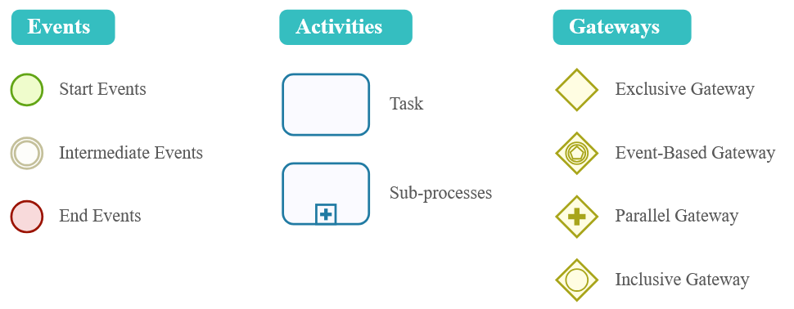
Figure 2. Business Process Modeling Notation (BPMN 2.0). www.bizagi.com

Table 3. Examples of software applications for Process mapping
Name | Features
Bizagi | Free, user-friendly
Bonita | Free, user-friendly, suitable for Mac users
Enterprise Architect | Paid software, advanced modeling tools
Microsoft Visio | Paid software, focused on process mapping
- Invite stakeholders:
  - Invite relevant stakeholders, ensuring representation from all critical groups (refer to interest vs power grid)
  - Provide stakeholders with the draft BPM and workshop agenda to encourage active participation and preparation.
- Set objectives: Clearly define the objectives of the workshop:
  - Validate and refine the draft BPM.
  - Identify gaps and align on stakeholders’ data needs.
  - Assess system strengths, weaknesses, and opportunities for SRS integration.

Step 2: Day 1 – Reviewing the draft BPM
- Introduction and context Setting:
  - Present an overview of the current mortality surveillance system and the purpose of implementing SRS.
  - Explain the BPM as a tool to visualize stakeholders, processes, and data flows.
- Review the draft BPM:
  - Walk stakeholders through the draft BPM, highlighting key components (stakeholders, data flow, governance processes, etc.).
  - Facilitate discussions to validate the accuracy of the map:
    - Are all key stakeholders included?
    - Does the BPM reflect the actual data flow and processes?
- Refine the BPM:
  - Collect feedback on missing elements, inaccuracies, or misrepresentations.
  - Update the BPM in real-time during the workshop, involving stakeholders in the revision process.
Step 3: Day 2 – Identifying Gaps and Needs
- Facilitate Gap Analysis:
  - Discuss stakeholders’ current data needs vs. what is available in the existing system:
    - What data is missing or insufficient?
    - Are there gaps in coverage, accessibility, or quality?
  - Explore system weaknesses, such as bottlenecks, duplication of efforts, or lack of coordination.
- Assess Strengths and Opportunities:
  - Identify strengths in the current system that can be leveraged (e.g., existing digital tools, governance structures).
  - Highlight opportunities for integration and synergy between existing systems with focus on SRS implementation.

Step 4: Day 3 – Co-Creating solutions and strategies for improvement
- Explore SRS Integration:
  - Facilitate discussions on how SRS can address identified gaps and improve the current system.
  - Use the BPM to illustrate where and how SRS components can fit into the existing data flow and processes.
- Co-design Improvement Strategies: Brainstorm and prioritize strategies to improve the mortality surveillance system.

